**Muhammad Ali Jinnah University**

NAME: Muzzammil Muhammad Zahid

ID: SP16-BS-0080

SUBJECT: SOFTWARE TESTING

Teacher: Farman Ali Pirzado

ASSIGNMENT 1 AND 2

ASSIGNMENT 1

* Automated Script work at selenium to URL path define to which website to navigate the specific resources.
* Find element by css define in the web-script define userid and pass

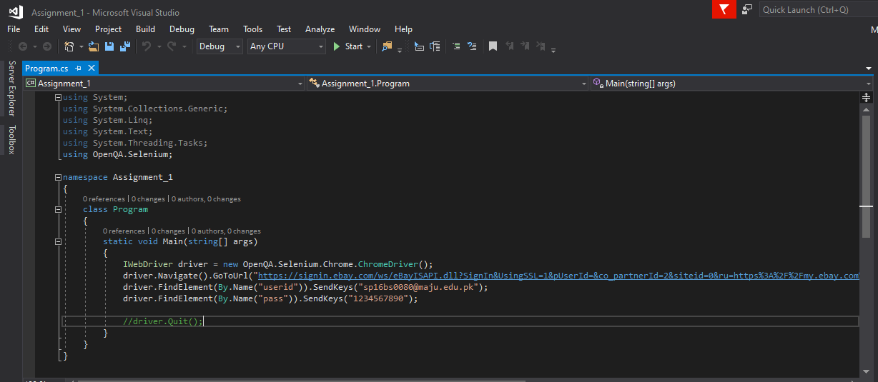

2nd screen for open cmd to generate which target at looked at file or not field.

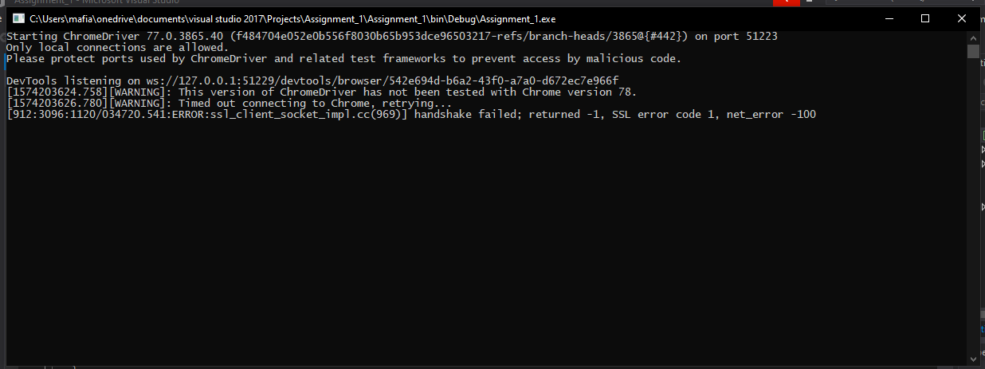

3rd screen shown in blow picture it's automation chrome browser automatically start and then field by field.

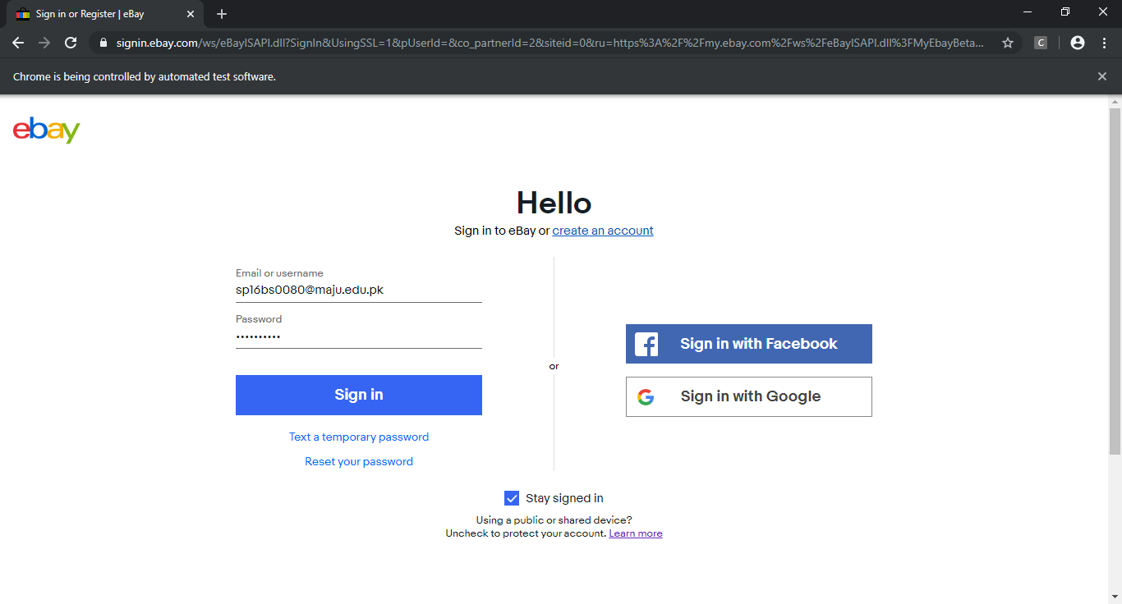

ASSIGNMENT 2

JMeter for java

* Provide URL in server name or below in this picture
* Get method used and folder path it's define at "/" means index of the URL path.

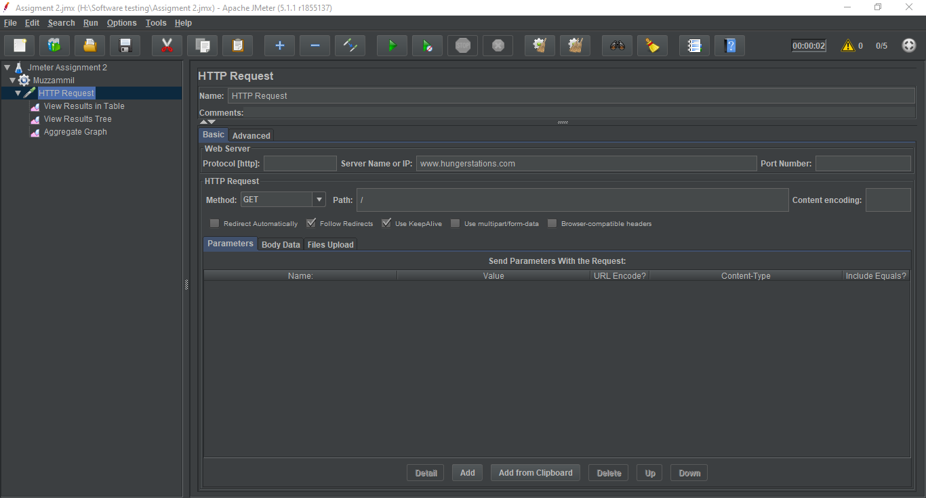

* In this below picture at setting for loop at 3 time repeat.
* Per-User request at least 5 times means number of thread.
* Sampler selection field is continued until work not been yet completed.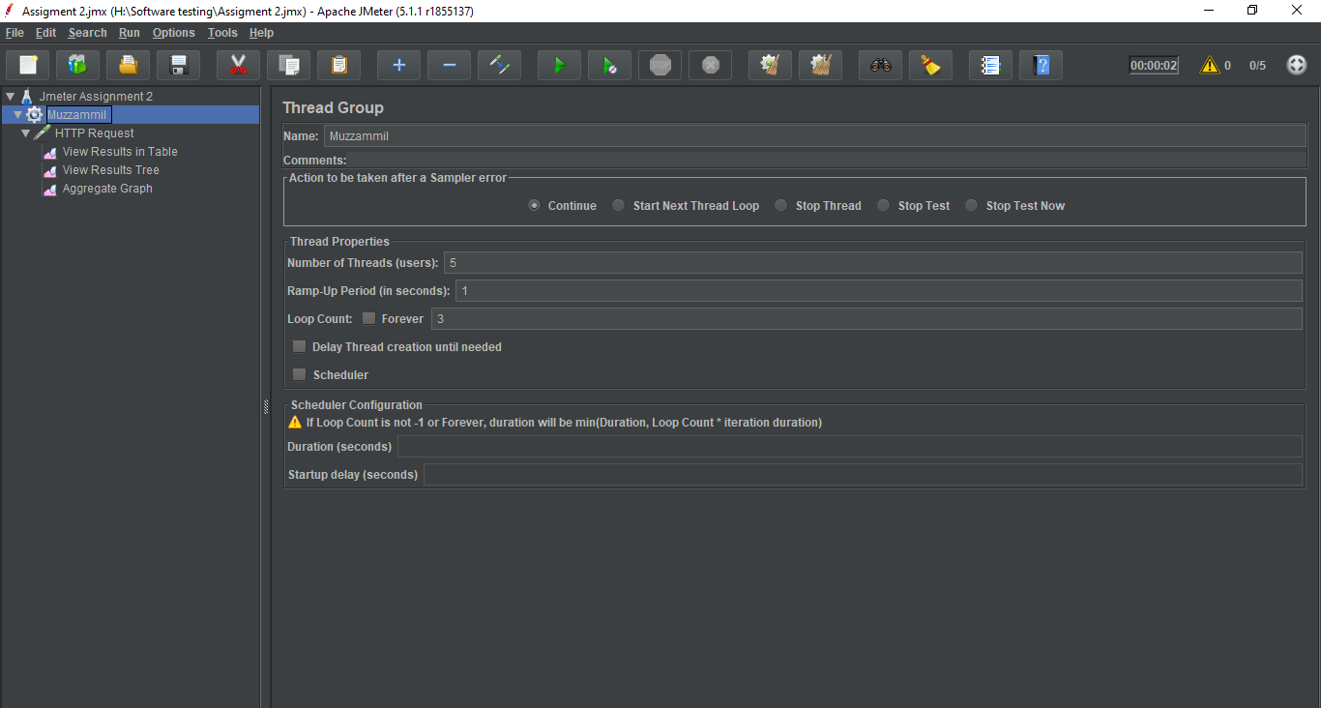
* In this below picture shown result in TABLE form.
* To provide 10 request in single threading.

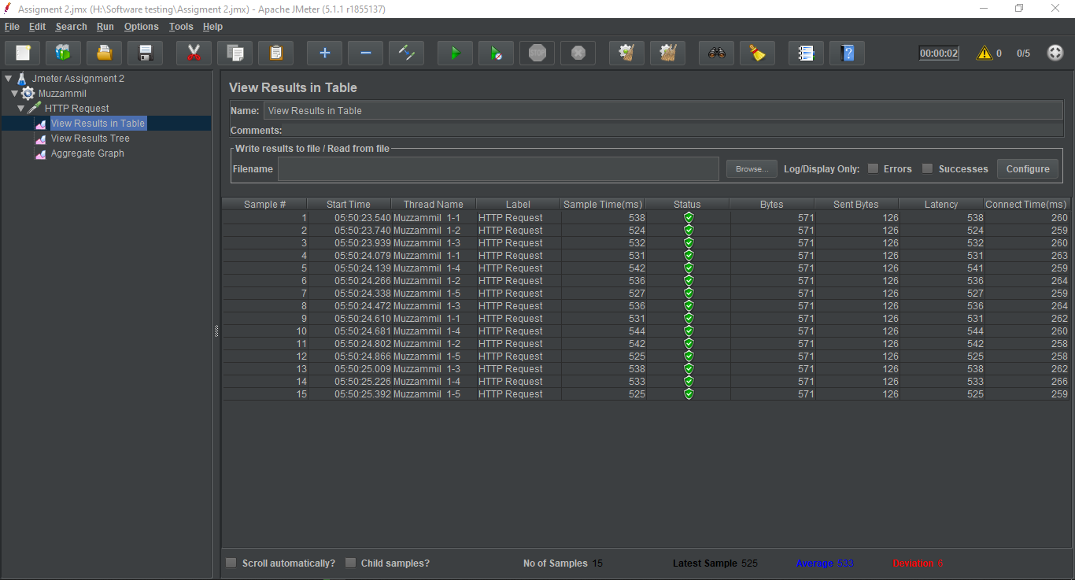

* In this below picture shown result in TREE.
* To provide 10 request in single threading.

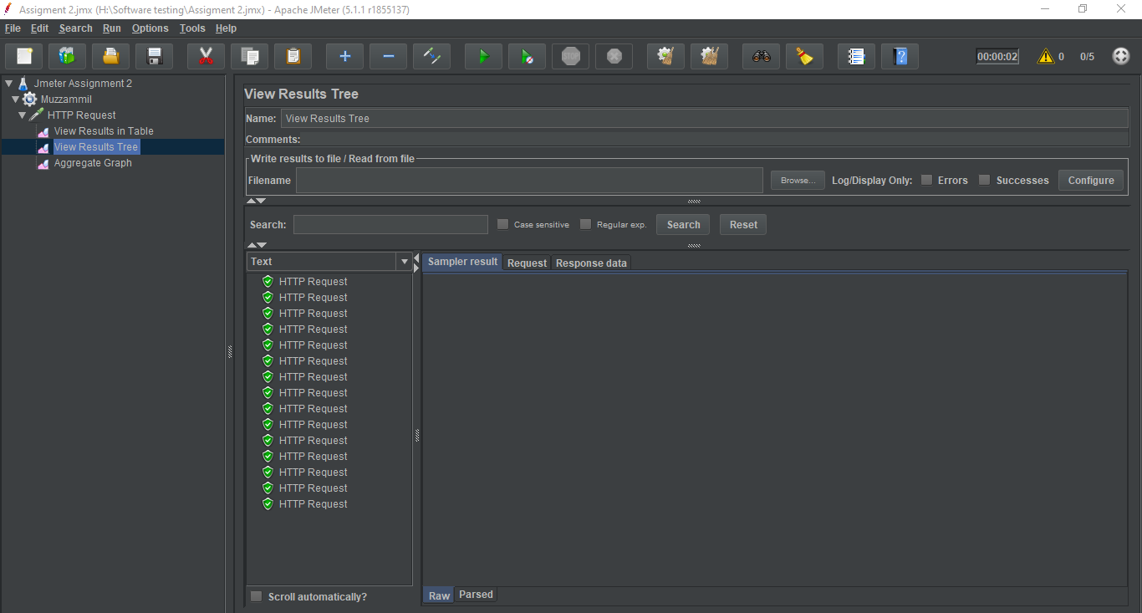

* In this below picture shown result in Graph.
* To provide 10 request in single threading.

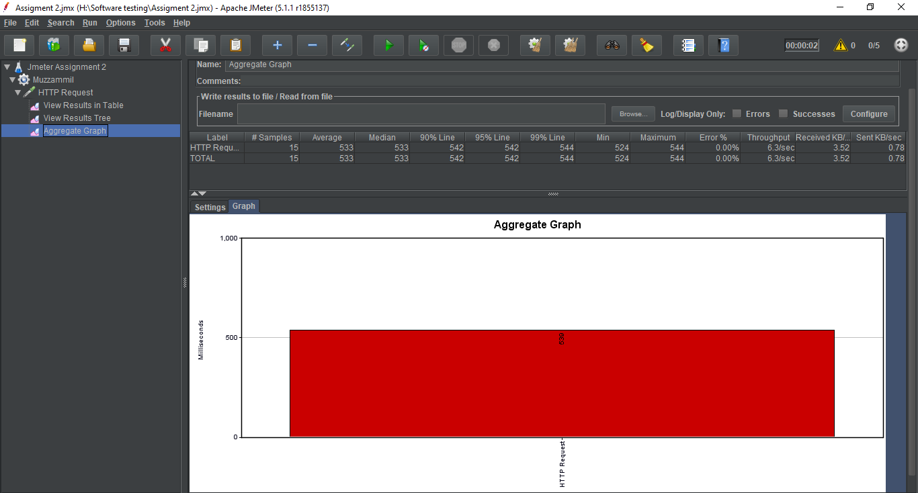

Thank You